Install GIT & make sure it is added into PATH.

Section 0 -Use GIT as local VCS. Steps to follow:

1. Create a directory ‘project_dir’ & cd to ‘project_dir’.

$ mkdir project_dir

$ cd project_dir

1. Initialize git version database. (git init)

$ git init

1. Create a new file index.html.

$ touch index.html

1. Check the git status. You should find index.html as untracked file.

$ git status

1. Stage the index.html file.

$ git add index.html

1. Commit index.html

$ git commit -m ‘Committing changes in index.html’

1. Make few changes in index.html & create a new file info.txt file.

$ touch info.txt

1. Check git status. You should find index.html & info.txt as untracked files.

$ git status

1. Configure GIT to ignore all txt files.

$ touch .gitignore

(Adding *.txt in .gitignore )

1. Again check the git status. You should find only index.html as untracked file.

$ git status

1. State & commit index.html

$ git add index.html

$ git commit -m ‘re-committing modified files’

1. Log all your comments so far.

$ git log

1. Make some changes in index.html.
2. Revert the change made in the previous step using git command.

$ git checkout --index.html

1. Again change index.html.
2. Stage index.html

$ git add index.html

1. Revert back the last stage.

$ git rm –cached index.html

1. Rename ‘add’ command to ‘my-add’.

$ git config --global alias . my-add add

1. Using my_add command Stage index.html again & commit the changes.

$ git my-add index.html

$ git commit -m ‘commit the changes’

1. Revert the last commit.

$ git revert 9adb273faae47fff4d422d417eb3b311c1885b58

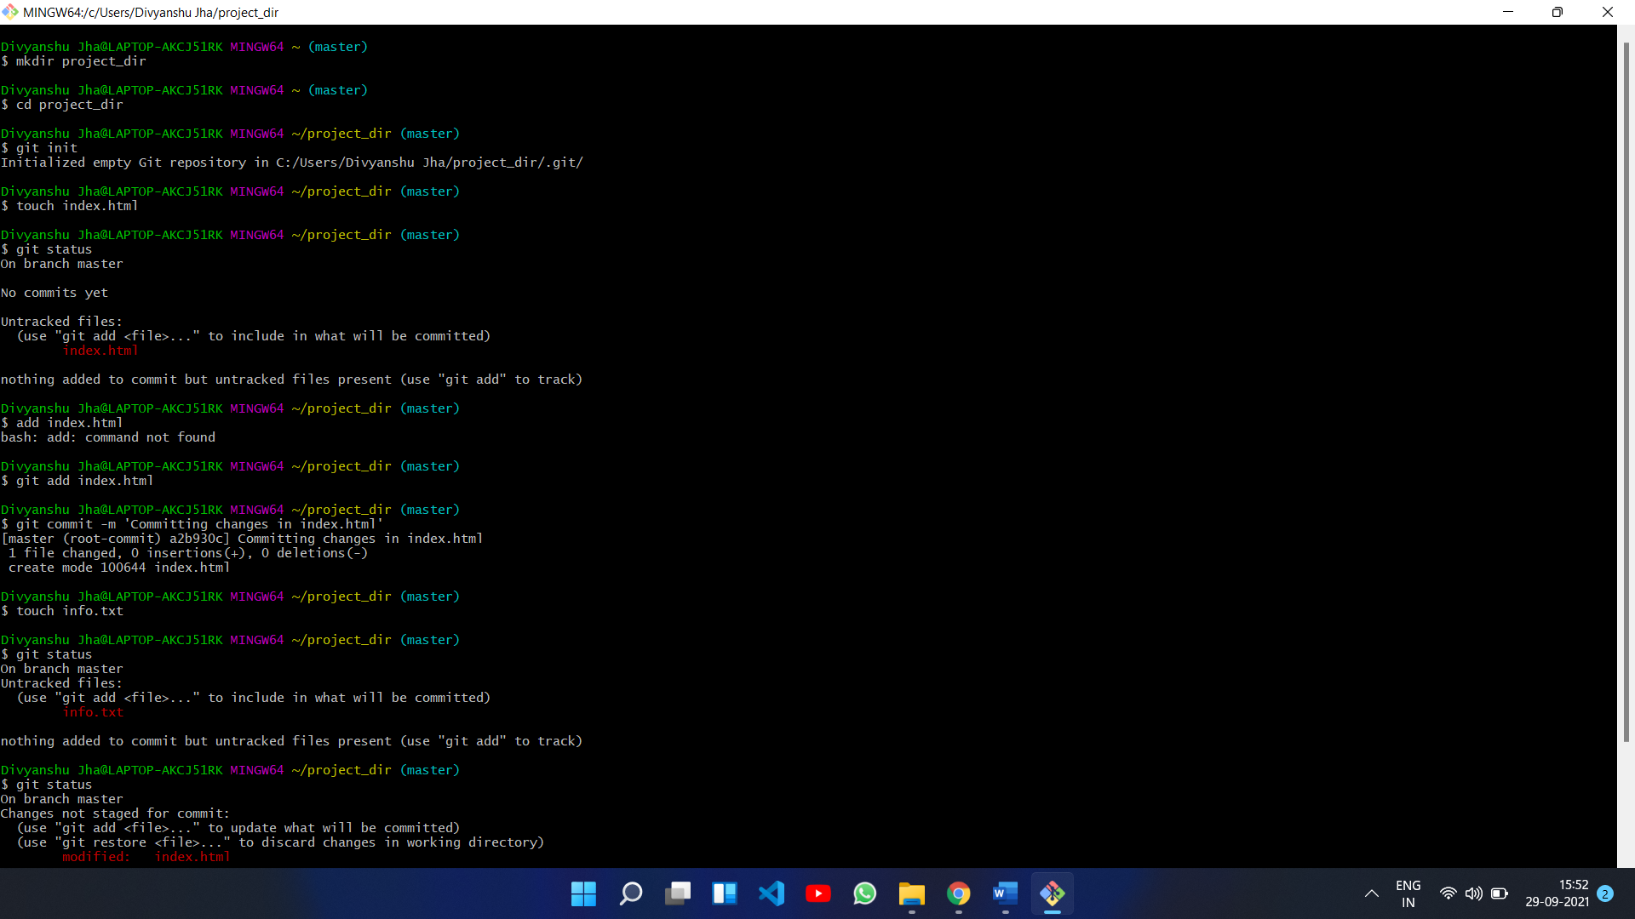

*GIT Branching*

Objective: Commit HTML, CSS & JavaScript assignments into GIT.

SECTION-1 (HTML assignments) - Steps to follow:

1. First take a backup of your assignments & projects. This is required because due to incorrect GIT operation you may lose your files.
2. Create an empty directory ‘Assignments’ & cd to ‘Assignments’.

$ mk dir Assignments

$ cd Assignments

1. Create a file README.txt inside ‘Assignments’ & write few lines about the contents of ‘Assignments’ folder.

$ touch README.txt

1. Commit README.txt file.

$ git add README.txt

$ git commit -m ‘commit README’

1. Now create a new branch ‘html-assignments’.

$ git branch html-assignment

1. Switch to ‘html-assignments’ branch.

$ git checkout html-assignments

1. Copy all HTML assignments inside ‘Assignments’ folder.
2. Commit HTML assignments into ‘html-assignments’ branch.

$ add *.html

1. Make minor changes into few files belonging to ‘html-assignments’ branch.
2. Commit those changed files.

$ git commit -am “Committing Modifications”

1. Switch to master branch.

$ git checkout master

1. Make minor changes into README.txt file & commit those changes into master.

$ git add README.txt

$ git commit -m “Committing README changes”

1. Again, switch to ‘html-assignments’ branch.

$ git checkout html-assignments

1. Make minor changes into few files belonging to ‘html-assignments’ branch.
2. Commit those changes.

$ git commit -m “committing changes in branch file”

1. Switch to master.

$ git checkout master

1. Merge ‘html-assignments’ branch into master. Confirm all html assignments are shown in master.

$ git merge html-assignment

1. Finally delete the ‘html-assignments’ branch.

$ git branch -d html-assignments

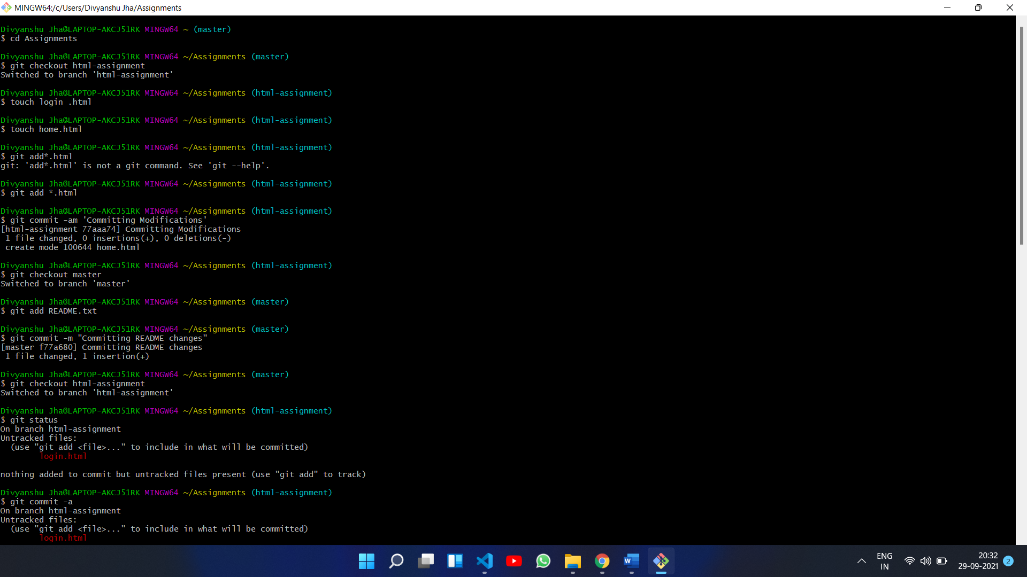

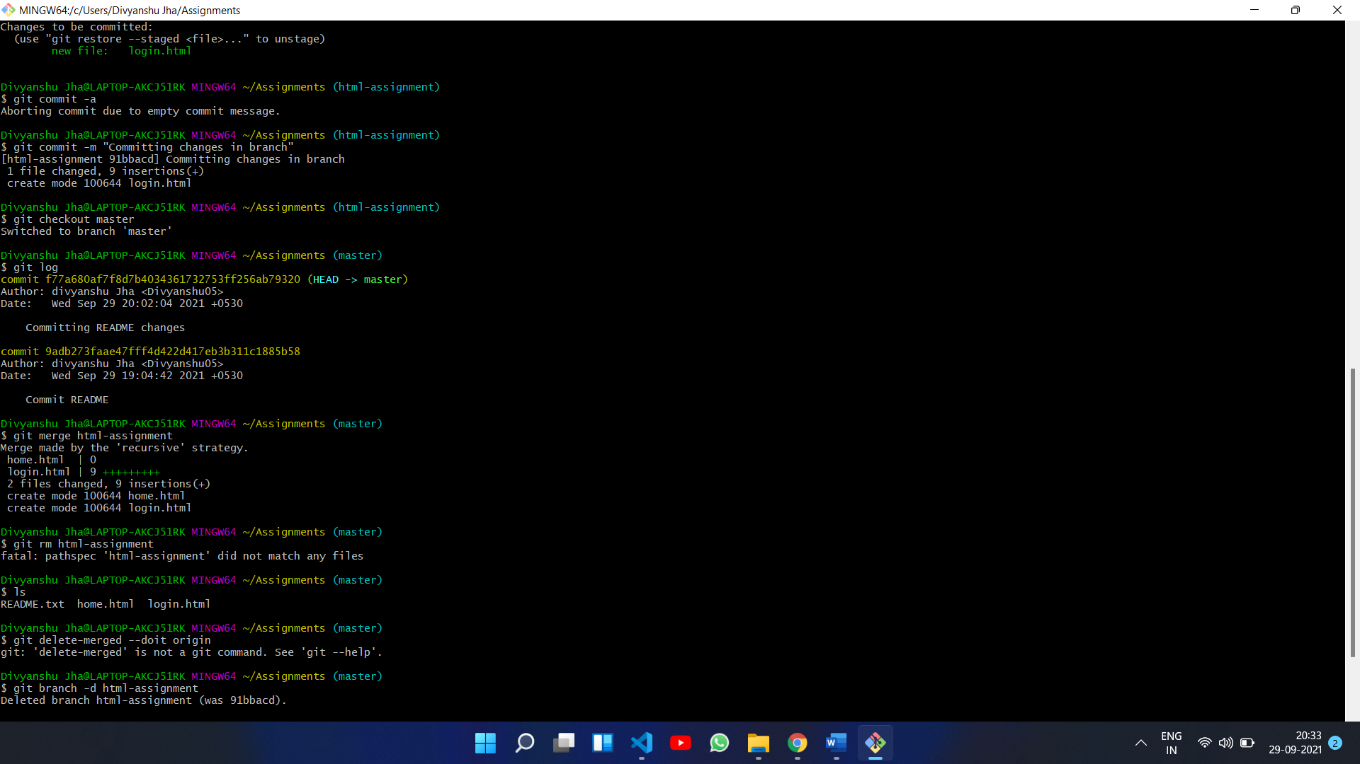

SECTION-2 - (CSS assignments) Steps to follow:

1. Create a new branch ‘css-assignments’.

$ git branch css-assignments

1. Switch to ‘css-assignments’ branch.

$ git checkout css-assignments

1. Copy all CSS assignments inside ‘Assignments’ folder.
2. Commit CSS assignments into ‘css-assignments’ branch.

$ git add *.css

$ git commit -m “commit css”

1. Make minor changes into README.txt file on line 1 belonging to ‘css-assignments’ branch.
2. Commit those changed files.

$ git add README.txt

$ git commit -m “README file css changes”

1. Switch to master branch.

$ git checkout master

1. Make minor changes into README.txt file on line 3 & commit those changes into master.

$ git add README.txt

$ git commit -m “Changes in README file”

1. Again switch to ‘css-assignments’ branch.

$ git checkout css-assignments

1. Make minor changes into few files belonging to ‘css-assignments’ branch.
2. Commit those changes.

$ git add *.css

$ git commit -m “minor changes in css”

1. Switch to master.

$ git checkout master

1. Merge ‘css-assignments’ branch into master. Confirm all css assignments are shown in master.

$ git merge css-assignments

1. Finally delete the ‘css-assignments’ branch.

$ git branch -d css-assignments

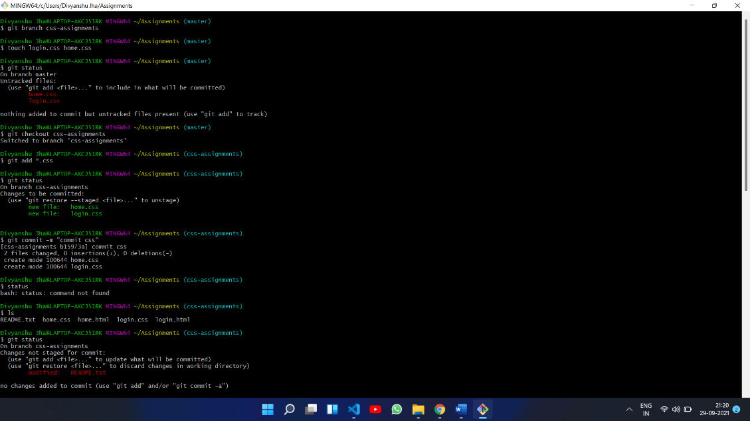

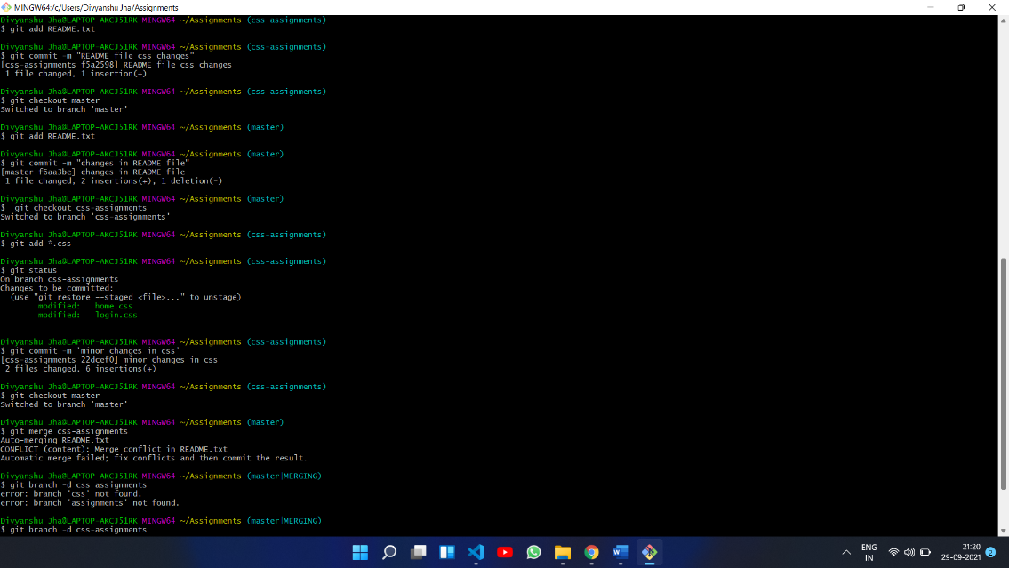

SECTION-3 - (JavaScript assignments) Steps to follow:

1. Create a new branch ‘js-assignments’.

$ git branch js-assignments

1. Switch to ‘js-assignments’ branch.

$ git checkout js-assignments

1. Copy all JavaScript assignments inside ‘Assignments’ folder.
2. Commit JavaScript assignments into ‘js-assignments’ branch.

$ git add *.js

1. Make minor changes into README.txt file on line 1 belonging to ‘js-assignments’ branch.
2. Commit those changed files.

$ git add README.txt

$ git commit -m “Commit js”

1. Switch to master branch.

$ git checkout master

1. Make minor changes into README.txt file on line 1 & commit those changes into master.
2. Again, switch to ‘js-assignments’ branch.

$ git checkout js-assignments

1. Make minor changes into few files belonging to ‘js-assignments’ branch.
2. Commit those changes.

$ git add .

$ git commit -m “changes”

1. Switch to master.

$ git checkout master

1. Merge ‘js-assignments’ branch into master. Confirm all JavaScript assignments are shown in master.

$ git merge js-assignments

1. Finally delete the ‘js-assignments’ branch.

$ git branch -d js-assignments

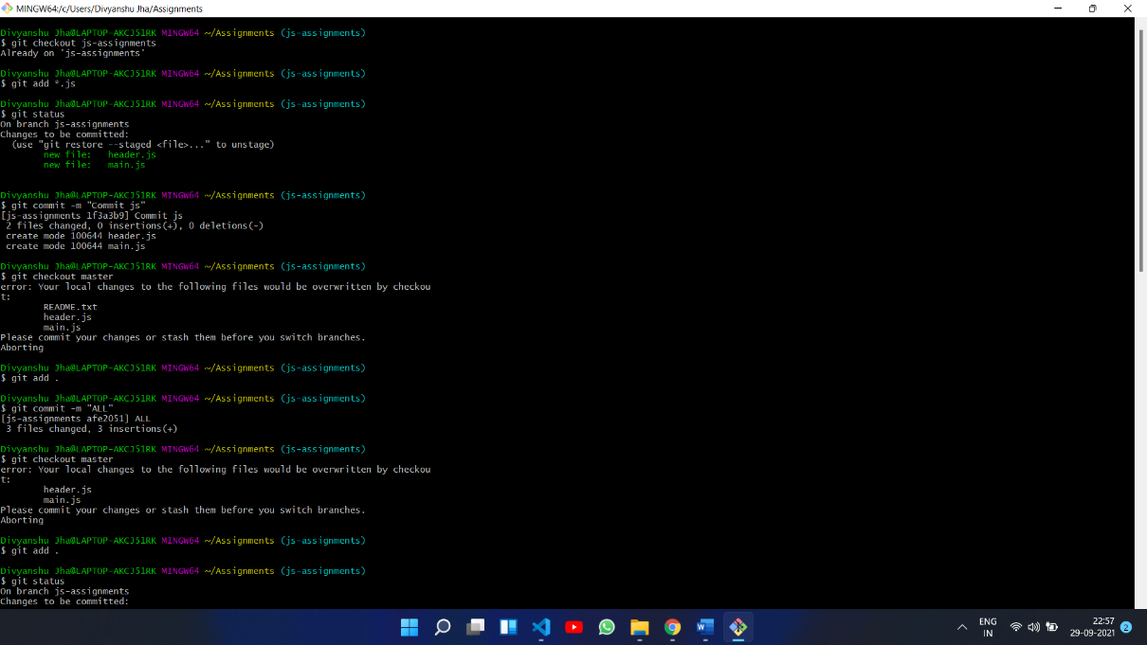

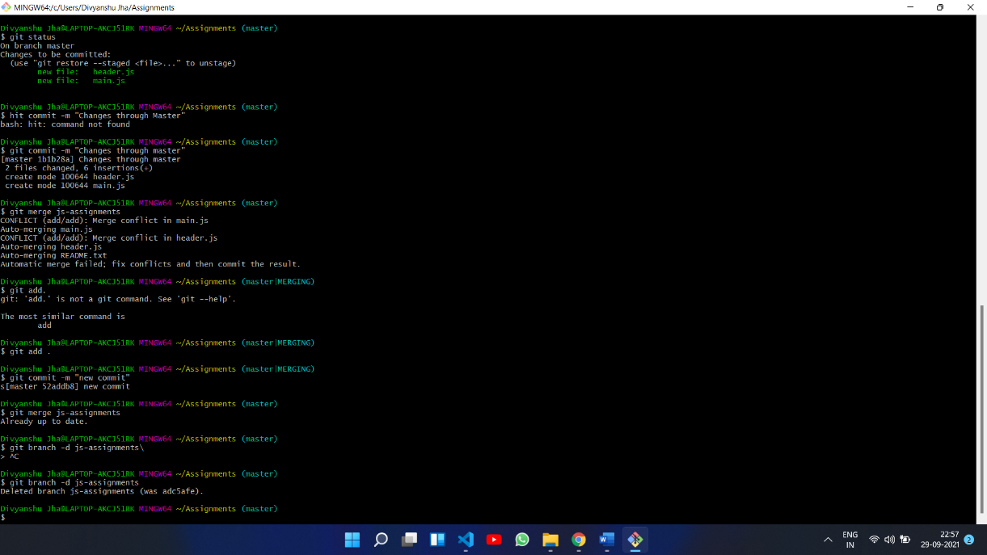

*GIT Remoting*

Objective: Pushing source code into GITHUB & collaborate team members.

SECTION-3 (Pushing assignments to remote repository) - Steps to follow:

1. Create a github account if you do not have already.
2. Login on into github account.
3. Create new public repository ‘freshersbatch-oct16’.
4. Commit & push any sample file to this repository under ‘Assignments’ directory.

$ git remote add origin https://github.com/Divyanshu05/Fresherbatch-sep21.git

$ git push origin master

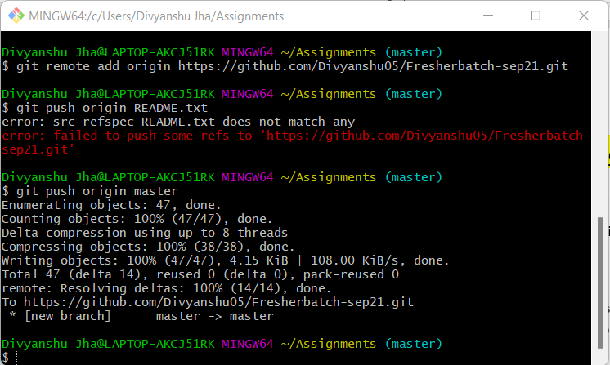

SECTION-4 (Pushing source code to remote repository using Eclipse GIT plugin) - Steps to follow:

1. One developer from project team will create eclipse projects ‘SampleProj’ & add sample source code files. Then commit all files through eclipse GIT plugin.
2. Collaborate other team members with your github account so that they can also modify the committed files.
3. Other developers from same team will checkout all files from remote repository. This might get conflicts since certain files fail to merge. In such case, merge it manually.
4. Commit & push the ‘SampleProj’ project.